**USER MANUAL Badminton Game Analysis System (GAS)**

Visit website <https://badminton-gas-03d473823731.herokuapp.com/>

Login detail for testing site:

**Username: Test**

**Password:** [**Test@test.com**](mailto:Test@test.com)

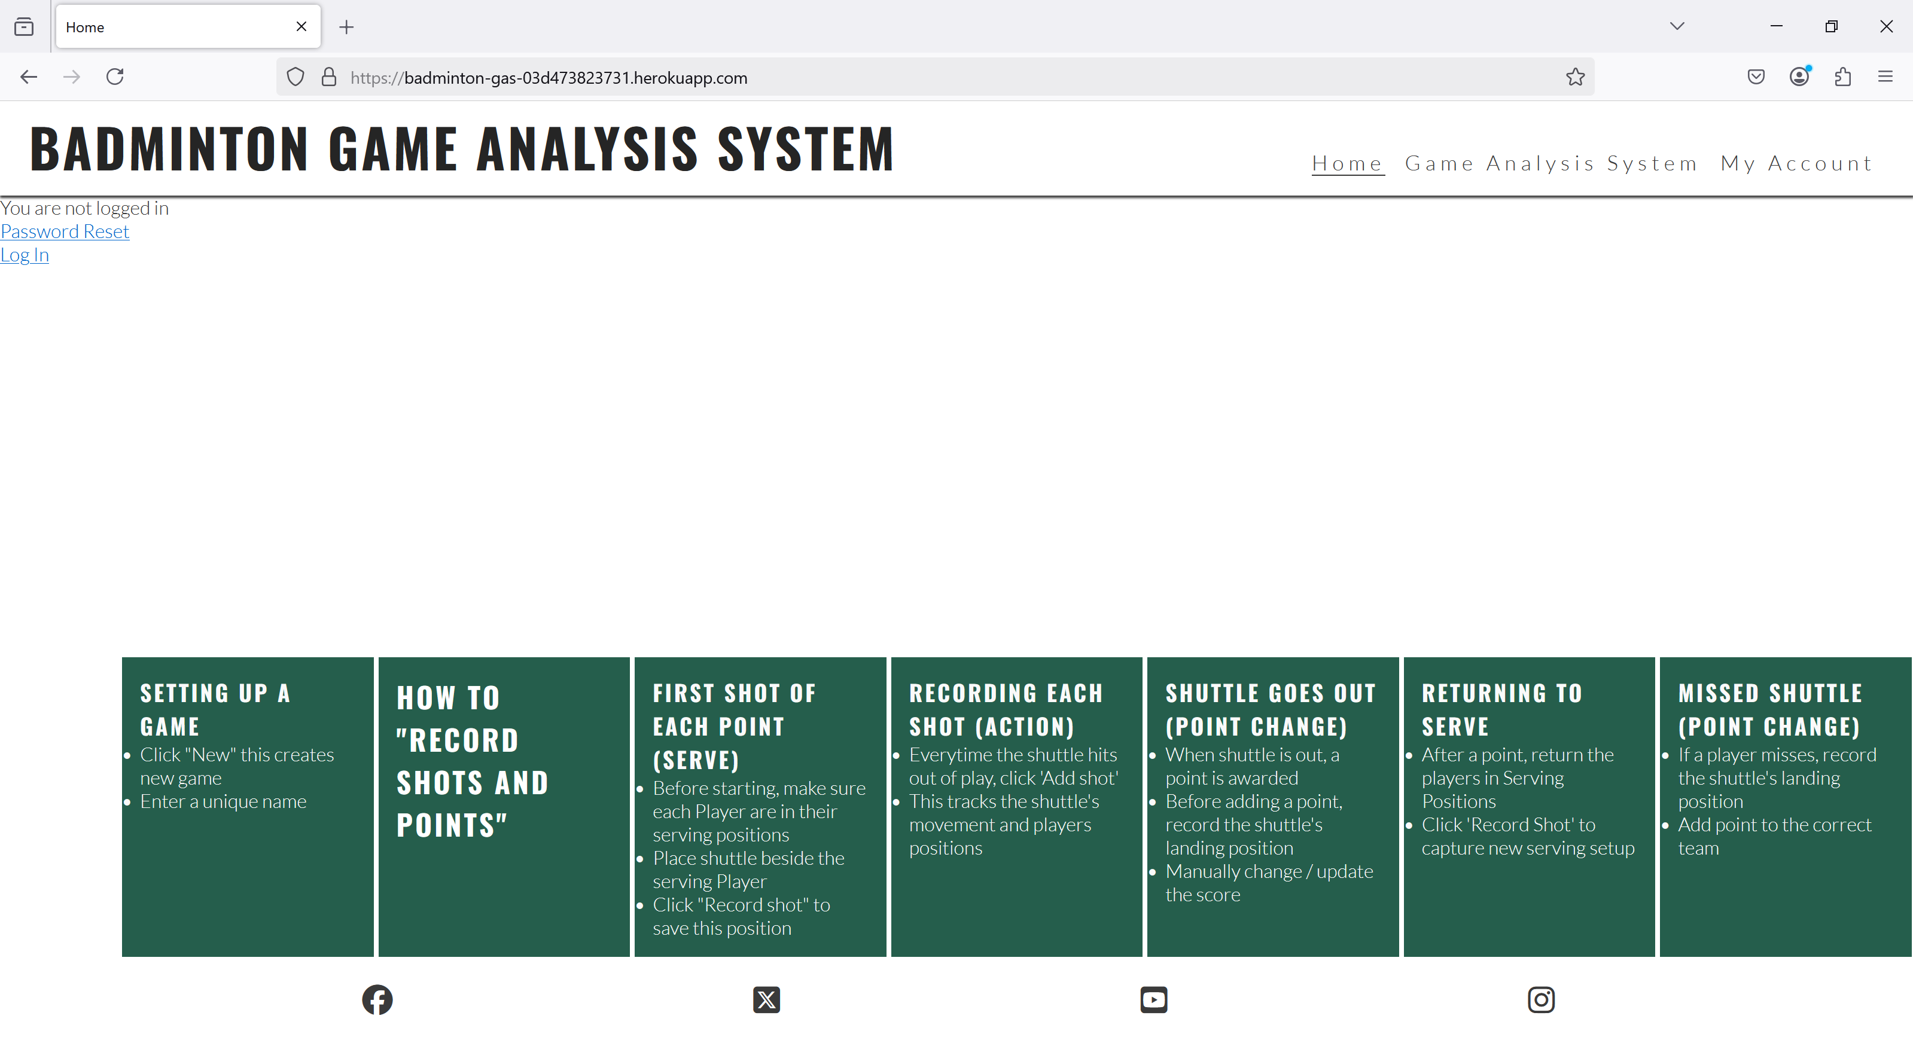

Select Log In

New page opens up, enter above details

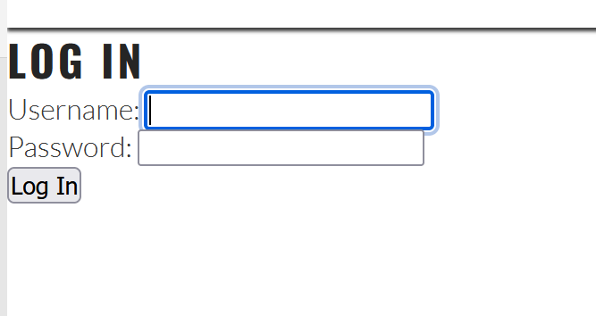

Welcome page opens up

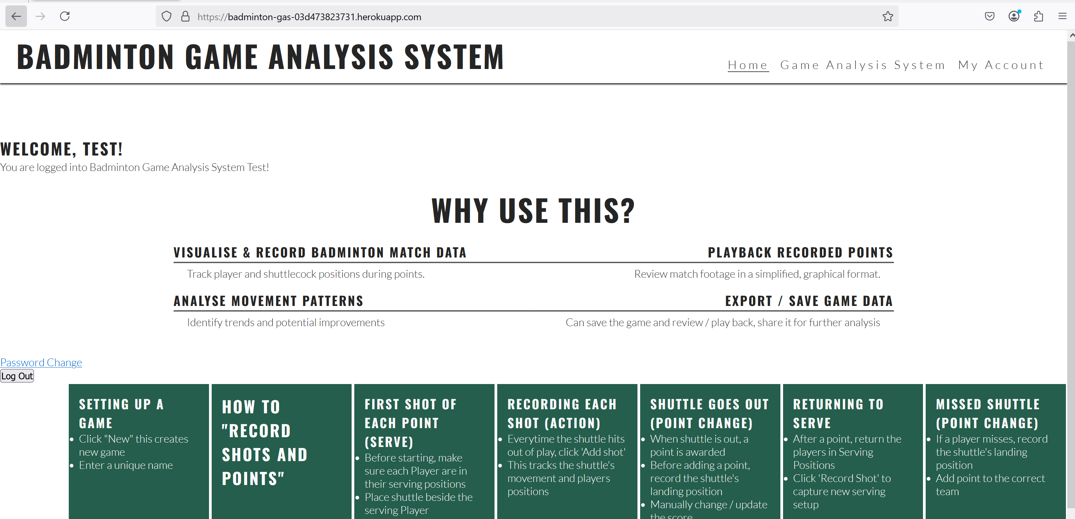

Go to **Game Analysis System** tab

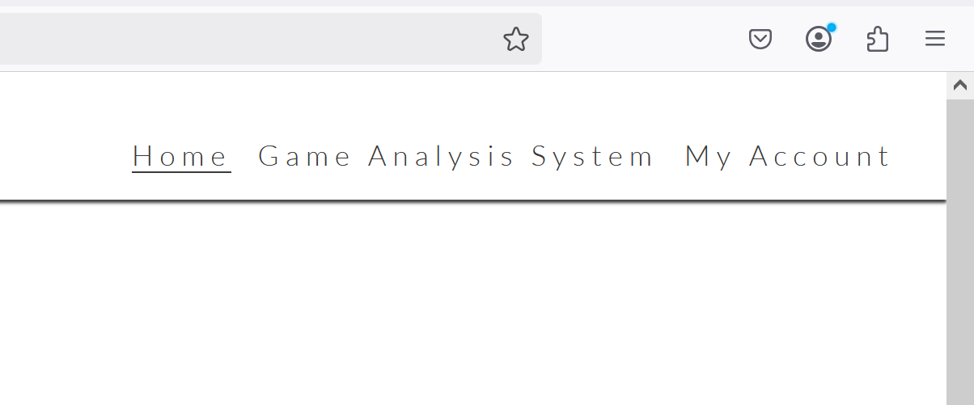

This will open up the Game Analysis System – Landing Page

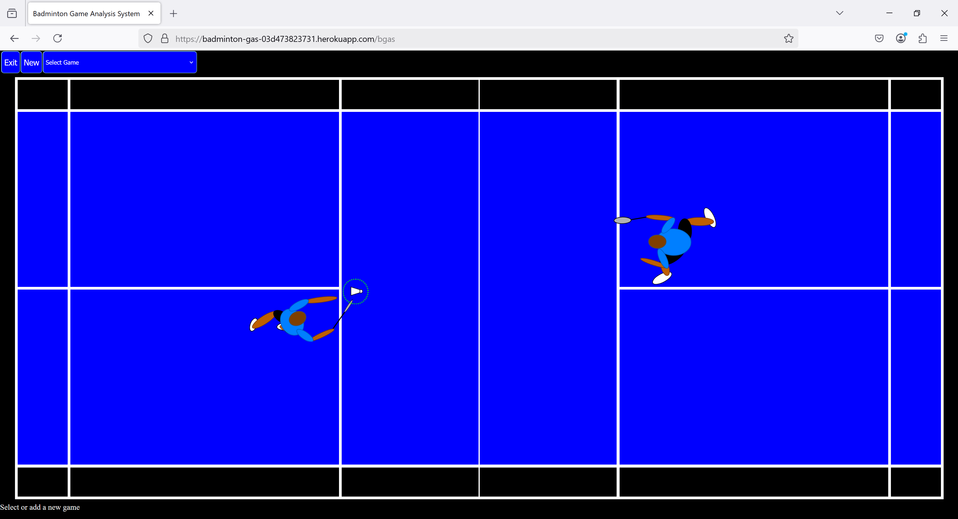

**Navigation**

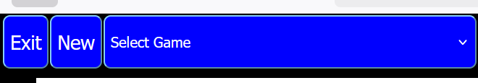

**Exit** – Takes user back to Home page

**New –** Create new game

**Select Game –** Select games previously saved

Note: default game on system is ‘Wang Yihan 0-0 Cheng Shao Chich (Olympics 2012)

Once a game is selected or a new game is created the name of the game appears on bottom of court.

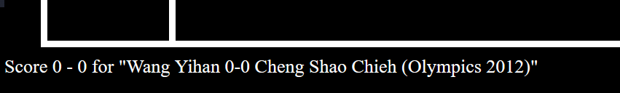

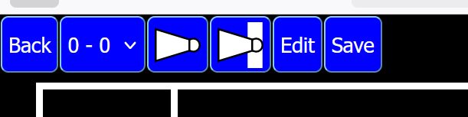

**Back –** Goes back previous page

**0 – 0 –** Game Points

Play point

Play all points to the End

**Edit –** edit mode

**Save –** Save game

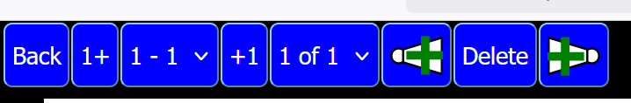

**Back –** Goes back to previous page

 adds a point to the player A

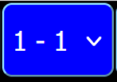 Point

 adds a point to the player B

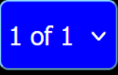 Shot

 Add shot PRIOR to current shot

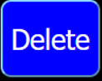 Delete shot

 shot AFTER current shot

**How to create a New Game**

Click New

Pop up box appears

Enter name of new game

Click OK

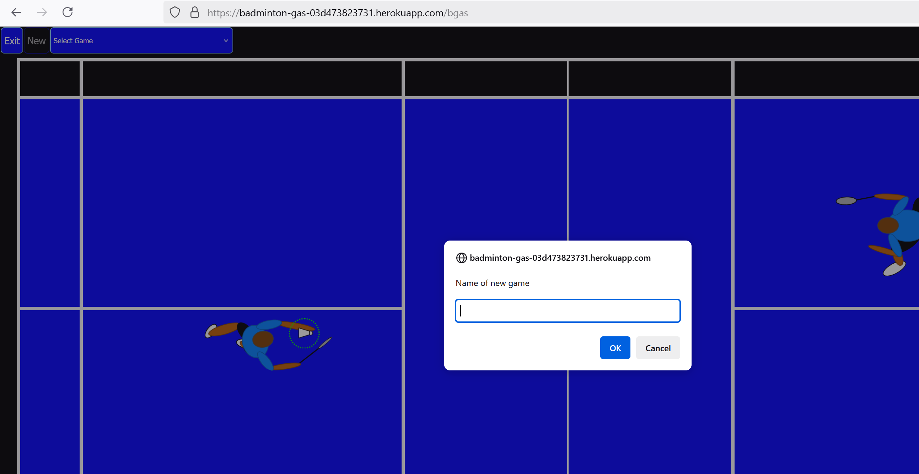

After you click **OK** the Navigation will change, name you’ve created will appear on bottom

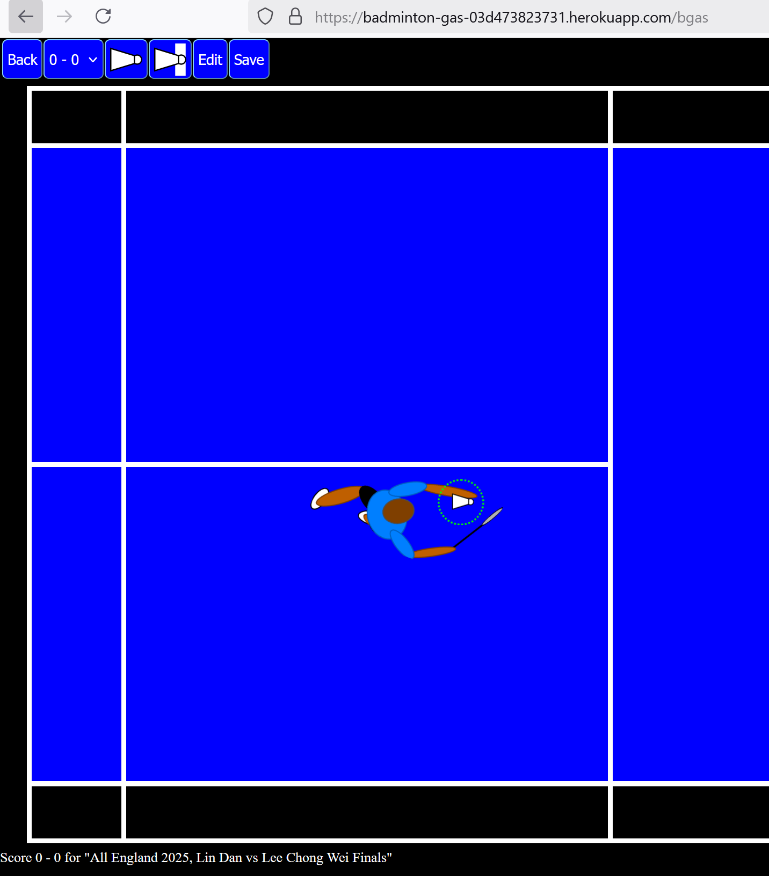

Click SAVE

This will automatically take you back to the first set of Navigation – where you have to select the Game you’ve created.

Select the game from the list

You can check the correct game is selected by checking the bottom of the screen

Click **Edit** to start editing a Game to playback

**Note:** ALWAYS Click the buttons on top **BEFORE** moving the players and shuttle to record the moves.

Follow the steps to create sequence of points/shots to play back for analysis

1. All games will start with 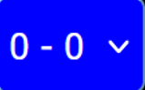 Points and 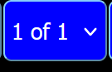 shot.
2. Players should be positioned in the START serving positions.
3. Remember the Rules of the Game
4. Player always serves from the right in at the start of the game. The subsequent serves will depend on the points/score.
5. You can move the players to where you want them to start the first serve/point. Or move the players to where they receive/play the shot to return the shuttle.

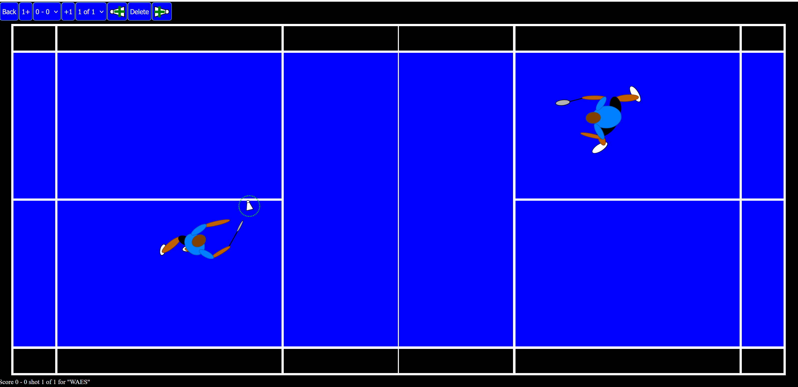

This is now recorded.

1. Next step Add a new shot – click  this will change the shot button to 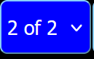
2. Now move the players and shuttle to the position that is played.

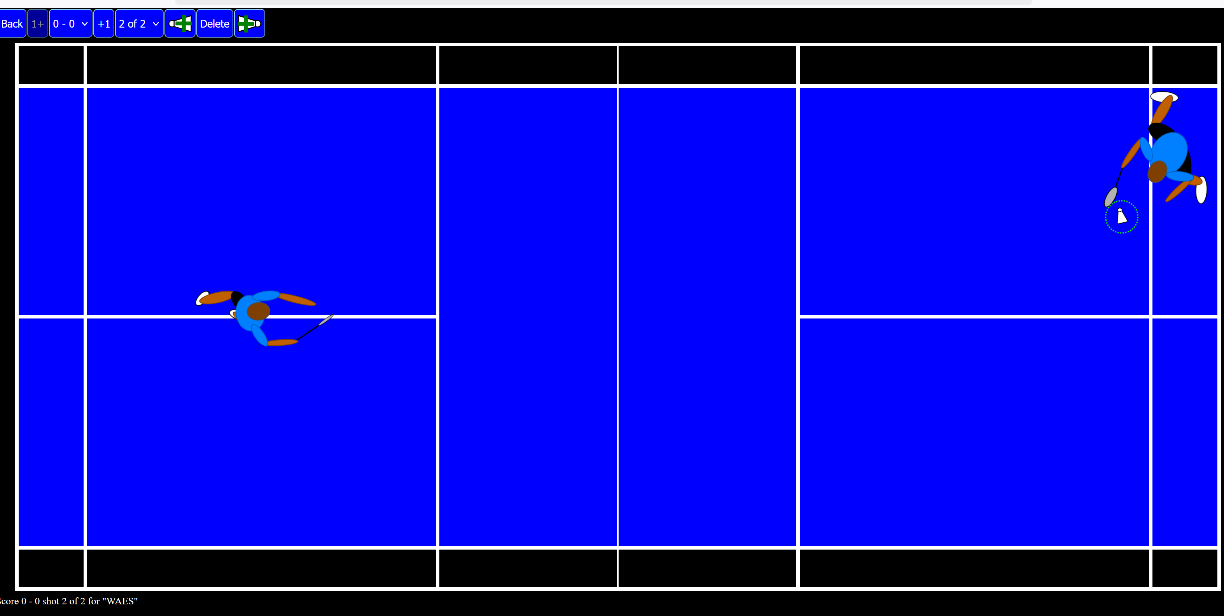

Repeat steps 6 and 7 until the shot is finished. (either the player missed the shot / shuttle played out)

Then move the players back to Serve position – step 4. And then repeat steps 5 to 7.

Remember you must change / add the points manually. Changing the score.

Once you’ve created the points and shots, click Back.

Example of shot being played OUT this means that the Point will now change to **0-1**

Note: point is awarded to the side that WON the point

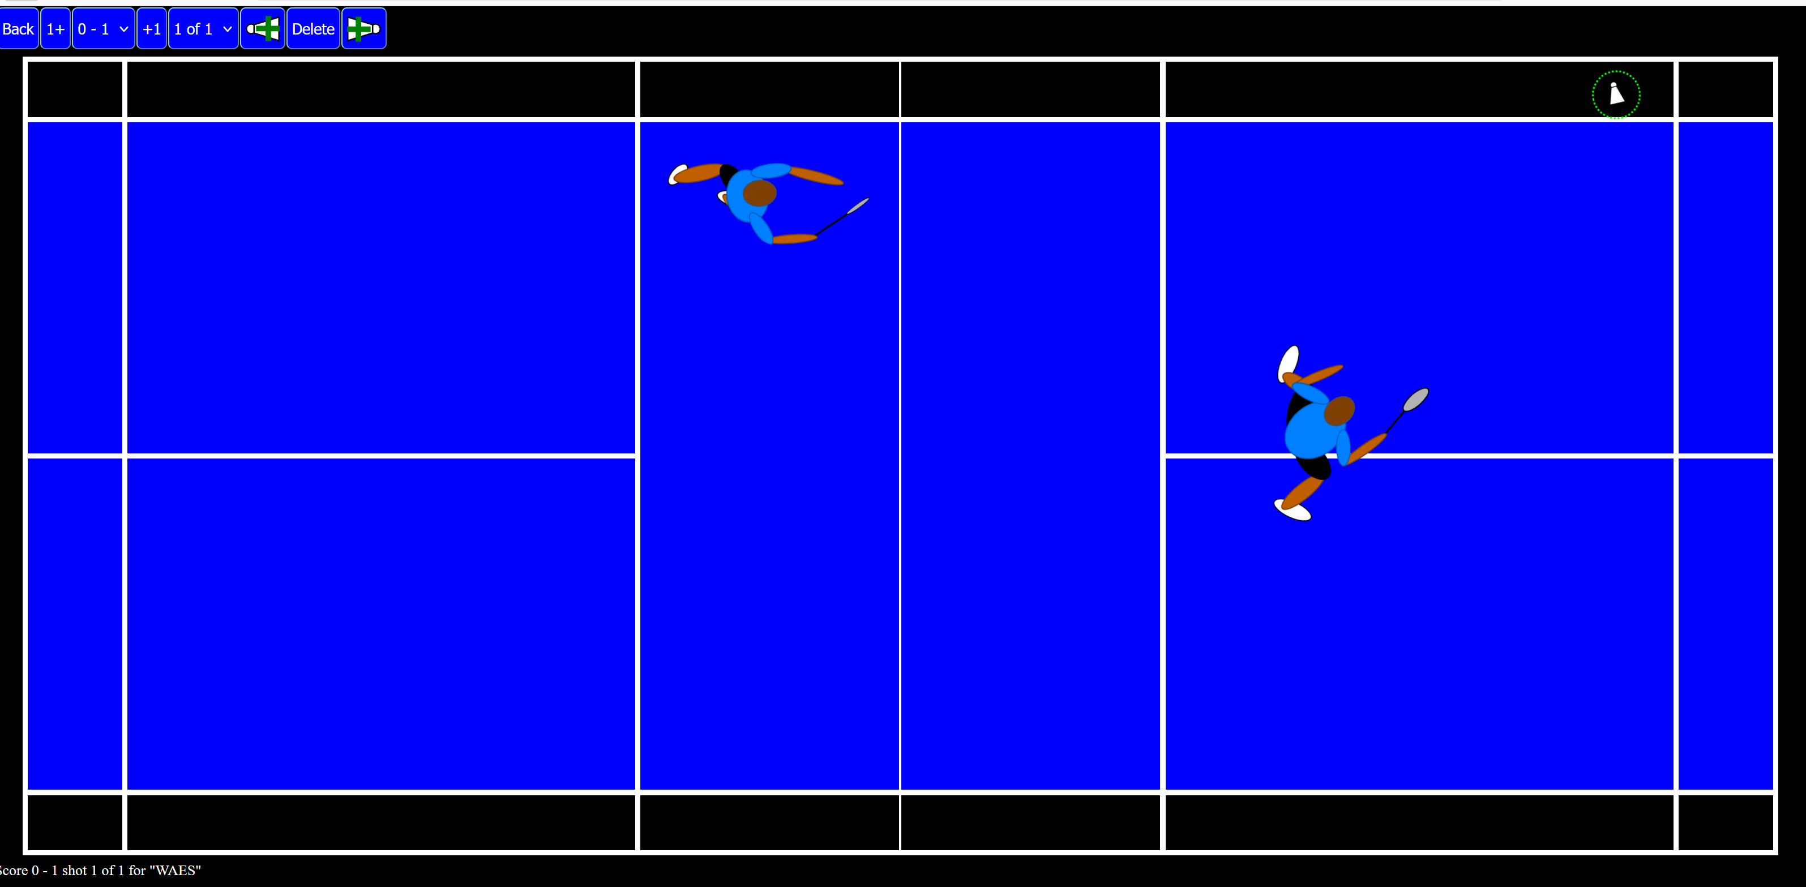

Click **Back** and then **Play** to check that the sequence of shots has been recorded correctly.